HackerRank Program 6
Link :- https://www.hackerrank.com/challenges/kangaroo/problem

Successful Submission
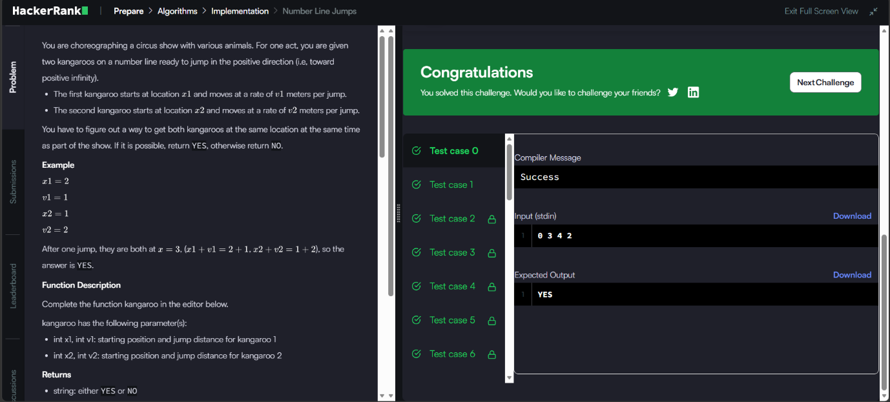
Source Code


